**DAILY ONLINE ACTIVITIES SUMMARY**

|  |  |  |  |  |  |  |  |
| --- | --- | --- | --- | --- | --- | --- | --- |
| **Date:** | **10 /06/2020** | | | | **Name:** | **Samrin Banu** | |
| **Sem & Sec** | **8th B** | | | | **USN:** | **4AL16C082** | |
| Online Test Summary | | | | | | | |
| **Subject** | | **-** | | | | | |
| **Max. Marks** | |  | | **Score** | |  | |
| Certification Course Summary | | | | | | | |
| **Course** | **GUVI** | | | | | | |
| **Certificate Provider** | | | **Python** | **Duration** | | | **26 hrs** |
| Coding Challenges | | | | | | | |
| **Problem Statement:**  1) Python program takes a number and reverses it | | | | | | | |
| **Status: Solved** | | | | | | | |
| **Uploaded the report in Github** | | | | **YES** | | | |
| **If yes Repository name** | | | | **Samrinbanu** | | | |
| **Uploaded the report in slack** | | | | **YES** | | | |

**Certification Course Details:**

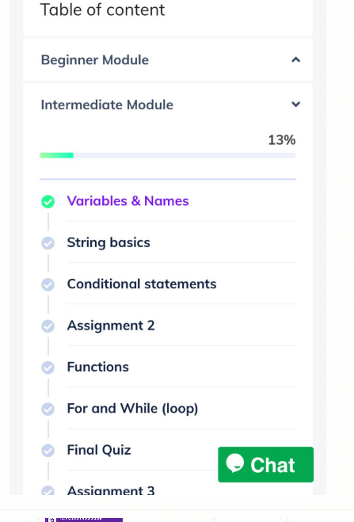



# CODE:

Program no:1

n=int(input("Enter number: "))

rev=0

**while**(n>0):

dig=n%10

rev=rev*10+dig

n=n//10

**print**("Reverse of the number:",rev)